Supplementary material for “A quantitative window on the history of statistics: topic-modeling 120 years of *Biometrika*”

By N. BERTOLDI

Département de philosophie, Centre Interuniversitaire de recherche sur la science et la technologie, Université du Québec à Montréal, 455 Boulevard René-Lévesque Est, Montréal (Québec) H3C 3P8, Canada, nicola.bertoldi87@gmail.com

F. LAREAU

Département d’informatique, Université du Québec à Montréal, 201 av. Président-Kennedy, Montréal (QC) H2X 3Y7, Canada, lareau.francis@courrier.uqam.ca

C.H. PENCE

Institut supérieur de philosophie, Université catholique de Louvain, place du Cardinal Mercier 14, bte L3.06.01, B-1348 Louvain-la-Neuve, Belgium, charles.pence@uclouvain.be

and C. MALATERRE

Département de philosophie, Centre Interuniversitaire de recherche sur la science et la technologie, Université du Québec à Montréal, 455 Boulevard René-Lévesque Est, Montréal (Québec) H3C 3P8, Canada, malaterre.christophe@uqam.ca

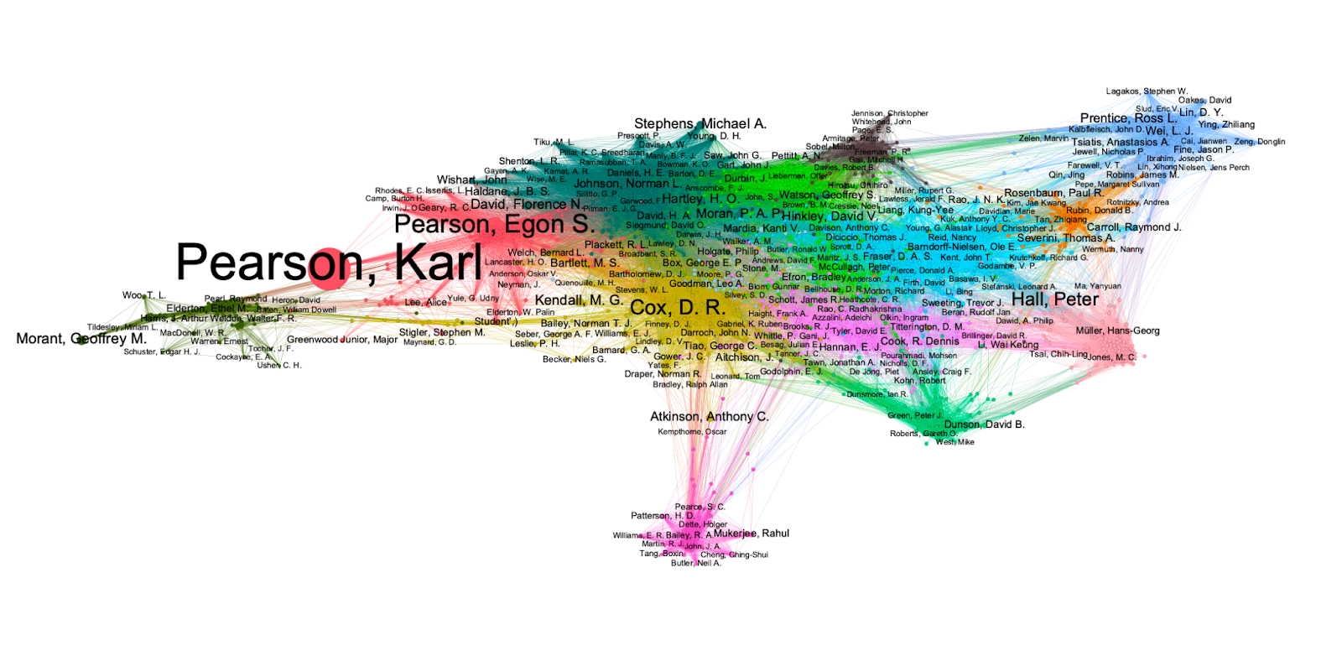

**Fig. S1.** Authors and communities in Biometrika (1901-2020). Nodes represent authors; node size is proportional to author contribution to articles; only authors with contribution ≥ 1 are represented (1924 authors = top-42% of authors responsible for 4477 articles or 80% of all corpus articles); only authors with contribution ≥ 4 are labeled (224 authors = top-5% of authors); node color corresponds to author community based on Louvain community detection as implemented in Gephi (20 communities, arbitrary colors). Edges are proportional to author correlations in terms of topics; correlation threshold ≥ 0.7.